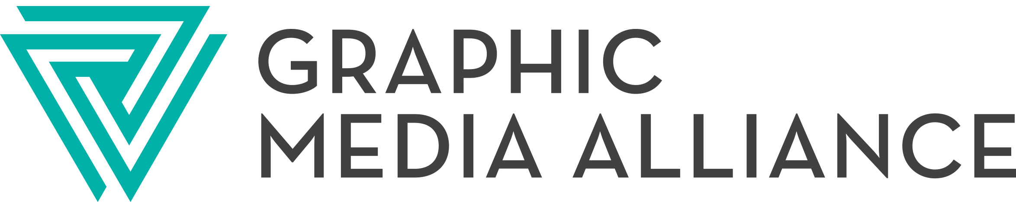

Do you have a Disaster Plan?

Fortunately printers do not often experience a disaster which interrupts their business operations but occasionally it happens. Storm damage, floods, fire, equipment breakdown, labor disputes, etc. can all bring production operations to a screeching halt and prevent or delay a company from fulfilling its customer’s needs. One can buy insurance to cover the cost of the damage and to recover the cost of additional business expenses but we still must serve our customers. If we don’t meet the customer’s needs quickly, everything else becomes unimportant.

For these reasons and a growing trend among print buyers (particularly those with term contracts) the GRAPHIC MEDIA ALLIANCE Board of Directors has directed the association staff to develop a mutual assistance plan for its members. GRAPHIC MEDIA ALLIANCE and its predecessor associations have always provided assistance to members in need. This has normally been in the form of out-placement of work, location of uncommon services and products or what ever else the need may be. However, it is felt that a more formal disaster assistance plan is appropriate to enable everyone to be protected and to demonstrate to our customers that we have taken steps to protect their interest as well.

The GRAPHIC MEDIA ALLIANCE Print Access database will enable us to locate specific equipment services but there is more to it than simply finding equipment. Subcontracting can be somewhat unnerving unless there is an agreement or mutual understanding that the subcontractor will not solicit business directly from the customer. Likewise, there needs to be some kind of understanding that the work is to be done at reasonable trade prices and on a workable delivery schedule.

GRAPHIC MEDIA ALLIANCE cannot and should not legislate all of these issues but can add to its database the names & capabilities of those members willing to participate in the new mutual assistance plan.

If you are willing to participate in this activity designed to help you and your customer, please complete the enclosed forms and return them to Jim Cunningham, GRAPHIC MEDIA ALLIANCE, P.O. Box 819, Westerville, Ohio 43086 or fax to: (614) 794-2049. If you have any questions, please call Jim at (888) 576-1971 or (614) 794-2300
We thank you for your interest & support. Upon receipt of your reply we will add you as a member of the new Disaster Mutual Assistance Program.

Disaster Mutual Assistance Plan (DMAP)

Non-Disclosure and Participation Form

Please add our company as a member of this new program. Enclosed is our Print Access information to add to the database.

We agree to the following:

- In the event assistance is needed, we will call GRAPHIC MEDIA ALLIANCE at (888) 576-1971 and ask for Jim Cunningham, President.
- In the event GRAPHIC MEDIA ALLIANCE calls our firm in behalf of another member needing assistance, we will respond favorably by offering to perform the services needed in a confidential manner subject to the following guidelines:
- Any relationship with the customer will be disclosed at the beginning of discussion between the firm outsourcing the work and the firm performing the work. This disclosure includes having the customer on a prospective call list.
- All discussions and outsourcing of the work will be strictly confidential and be conducted under the highest ethical standards.
- The printer or graphic arts firm performing the work shall agree not to contact the customer or solicit work from the customer for a period of one year.
- The work will be performed at reasonable trade prices, which are mutually agreed upon between the firm outsourcing the work and the firm performing the work.

Company: ___________________________________________________________________

Address: ____________________________________________________________________

Phone #: _____________________________ Contact: _____________________________

Comments: __________________________________________________________________

____________________________________________________________________________

